 

Report

of

Training of Safai Karamcharis under RPL Programme Supported by

National Safai Karamcharis Finance and Development Corporation

|  |  |
| --- | --- |
| **Qualification Pack** | Safai Karamchari (SGJ/Q6102) |
| **Training Duration** | 35 hours  Classroom Training (T) : 17 hours  Hands-on Training (P) : 16 hours  Assessment : 2 hours |

|  |  |  |
| --- | --- | --- |
| **Location Details of Training** | | |
| 1 | State | New Delhi |
| 2 | City | New Delhi |
| 3 | Municipal Corporation | Municipal corporation of Delhi |
| 4 | Ward | Civil lines zone |
| 5 | SCGJ Batch Number | 402383 |
| 6 | Uploaded on SDMS | Yes |

|  |  |  |
| --- | --- | --- |
| **Training Details** | | |
| 1 | Date of Screening Committee | 13/04/2018 |
| 2 | Date of Start of Training | 02/05/2018 |
| 3 | Date of End of Training | 08/05/2018 |
| 4 | Training Partner | Kaercher Cleaning Systems Pvt. Ltd |
| 5 | Principal Trainer (SCGJ Certified) | Tushar Gupta |
| 6 | Number of Candidates Registered | 49 |
| 7 | Number of Candidates Assessed | 38 |
| 8 | Number of Candidates Passed (list Enclosed) | 38 |
| 9 | Date of Medical Examination | 08/05/2018 |
| 10 | Number of Candidates medically examined | 38 |
| 11 | Payout to Candidates | NEFT(HDFC Bank) |
| 12 | Participant Handbook | Given to all candidates(39) |

Report of Training of Safai Karamcharis under RPL Programme

Model Town, Civil Lines, Delhi

Training Pics Day 1: Inaugural Day Pics

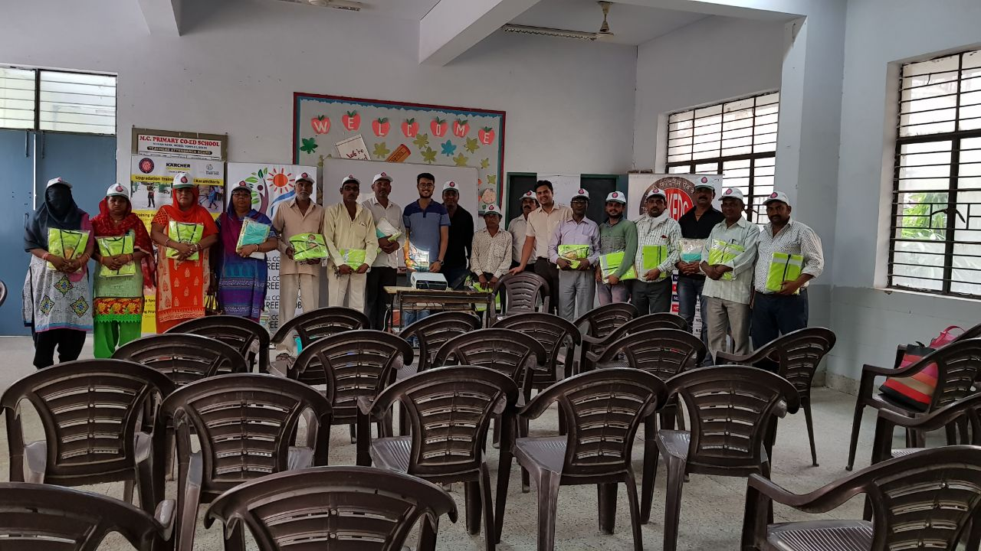

**35hrs training Kick-off in Civil Lines with Kit Distribution**

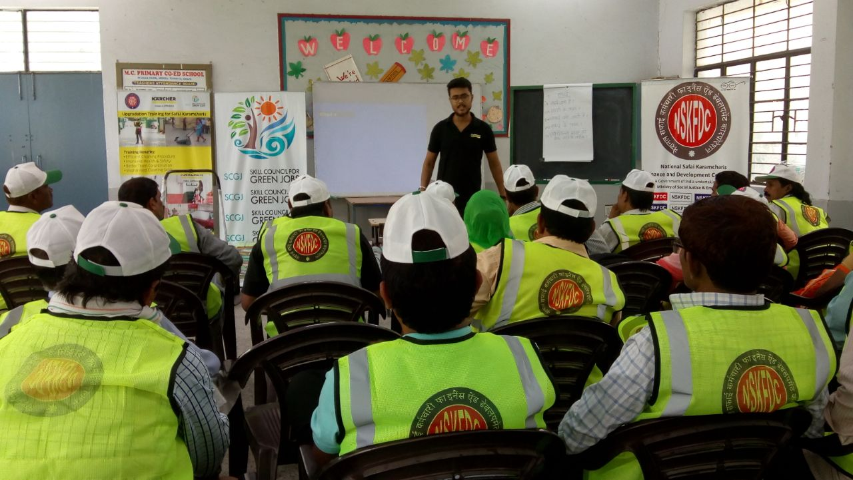

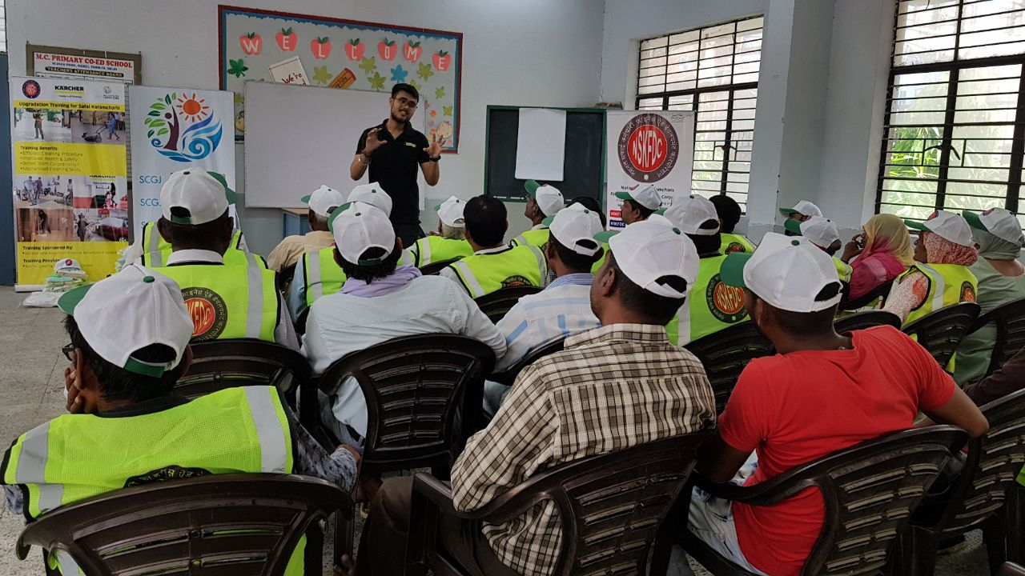

Training Pics Day 2 : Mechanized Cleaning : Vacuum cleaner Training

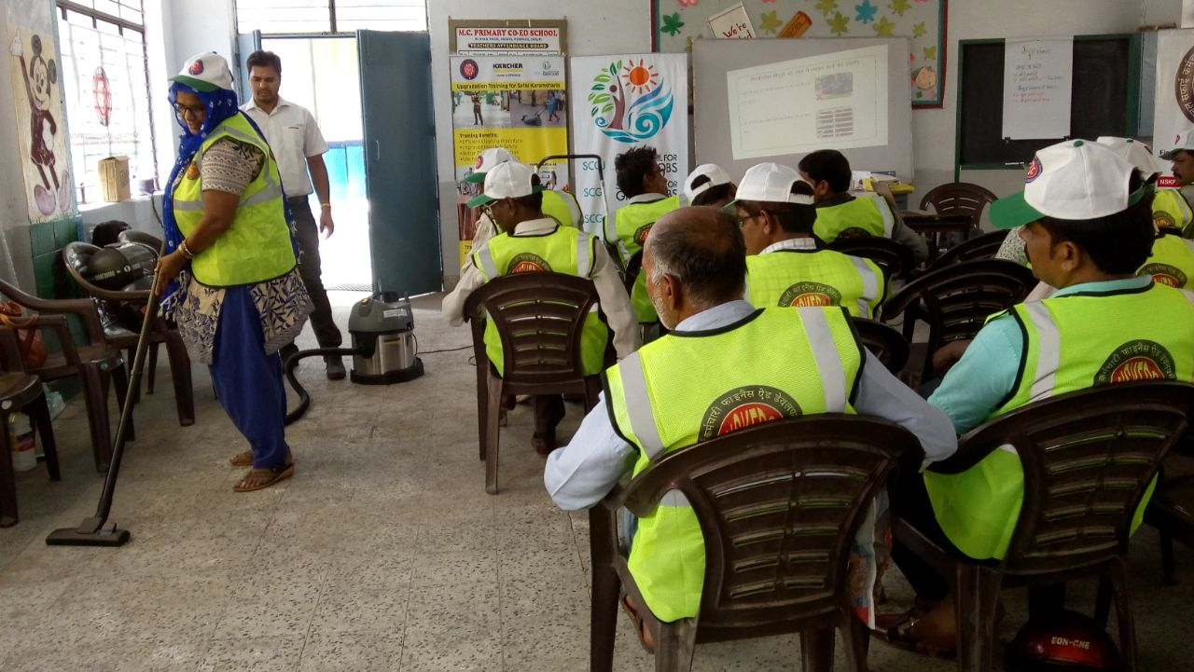

**Hands-on training**

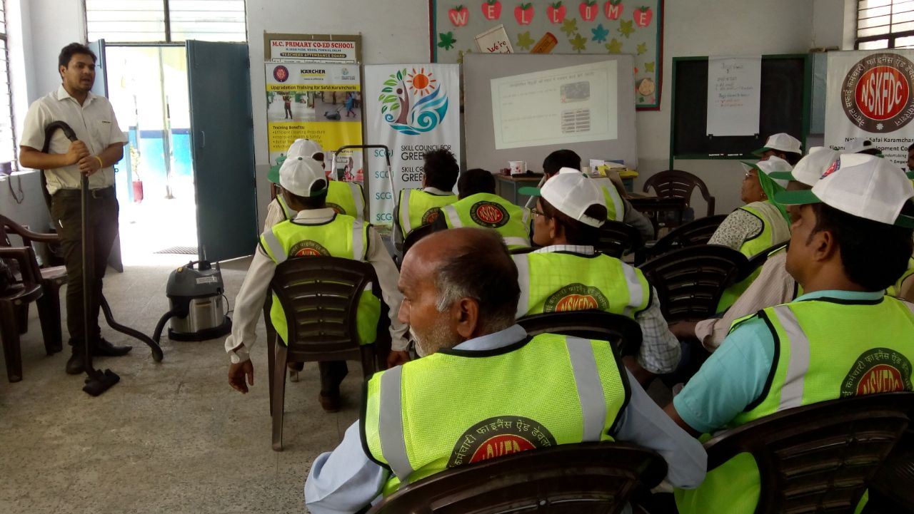

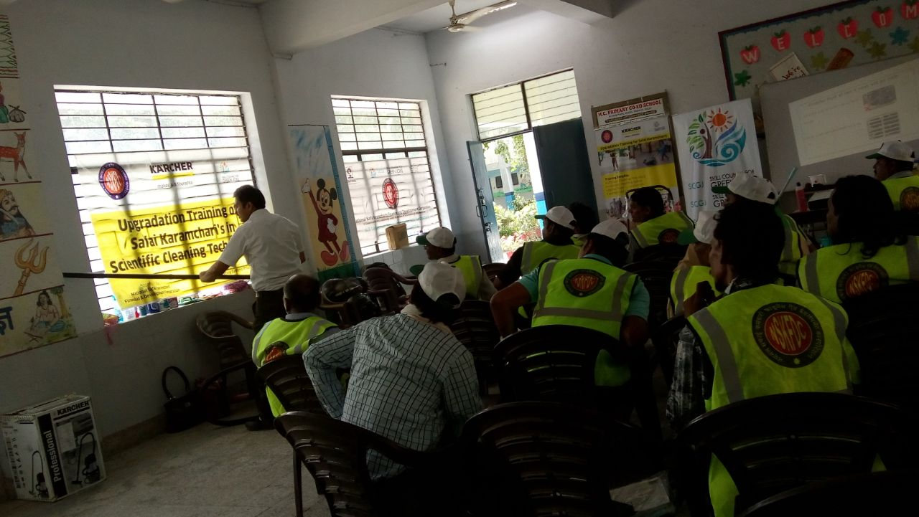

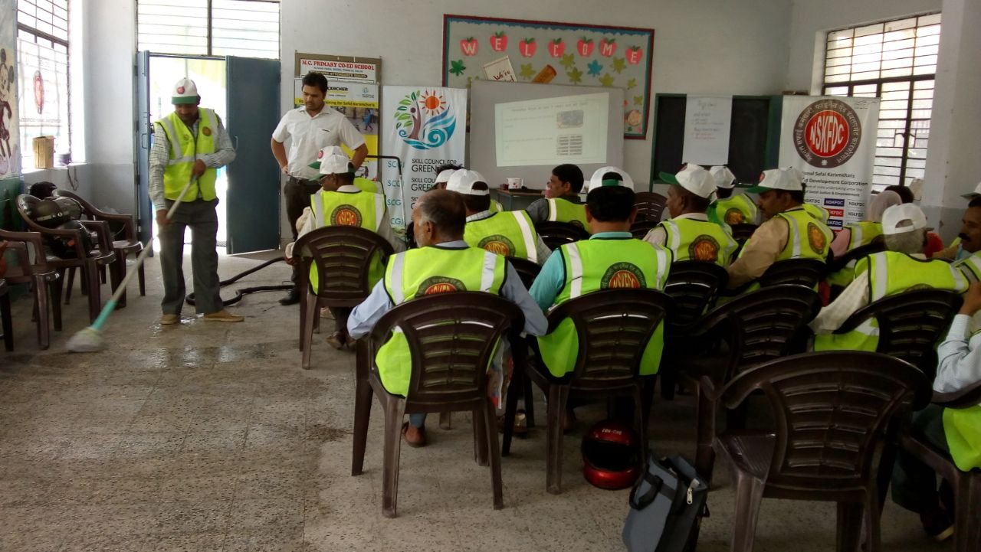

**Mopping technique**

Training Pics Day 3:

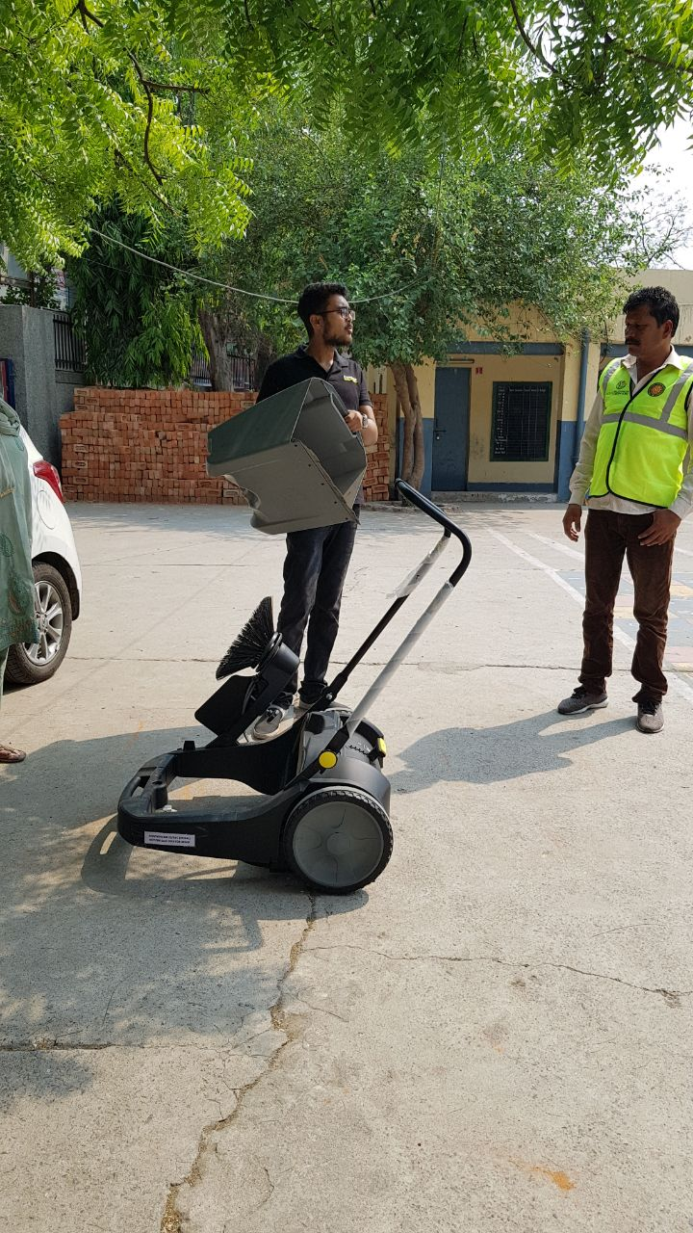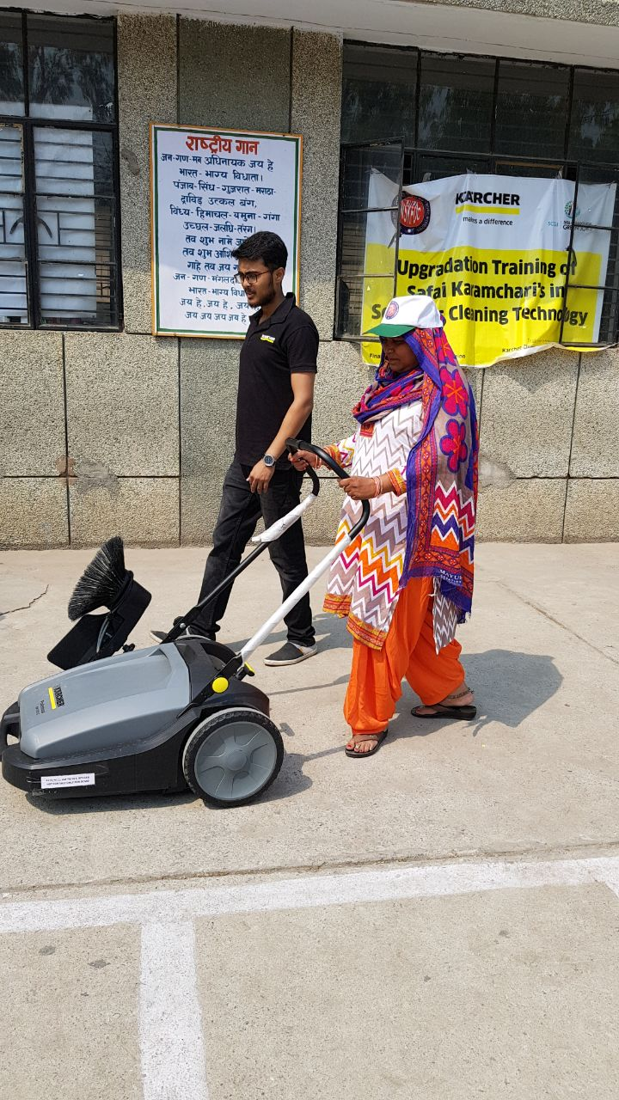

**Mechanization training on Sweeper machine**

Training Pics Day 4

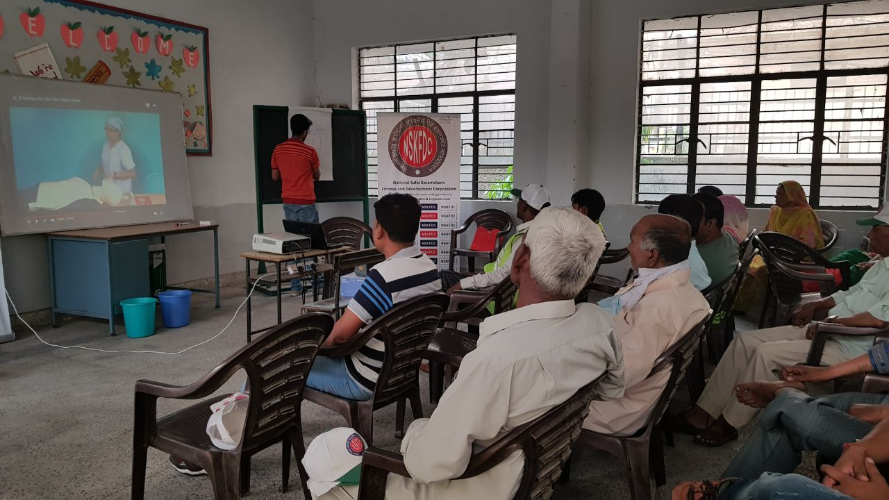

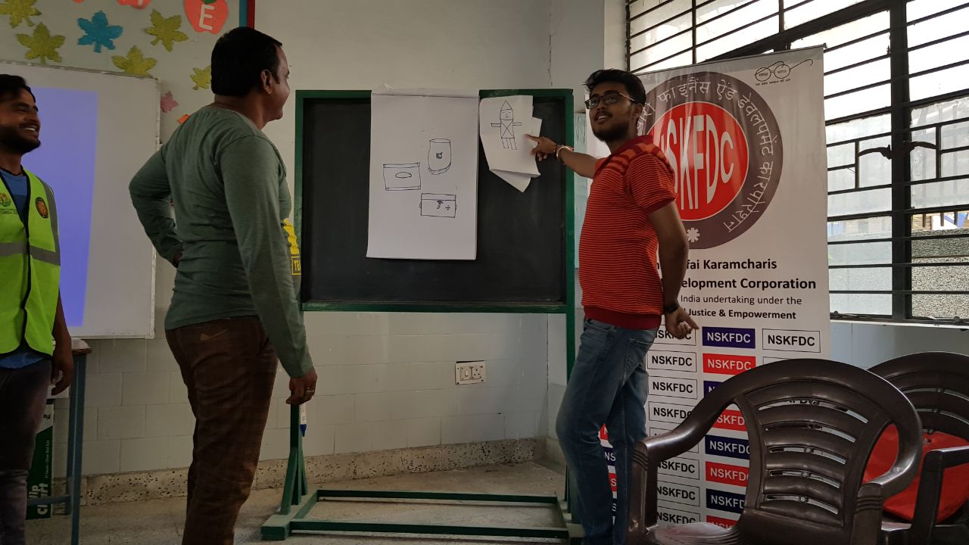

**Activity on communication skills**

Training Pics Day 5

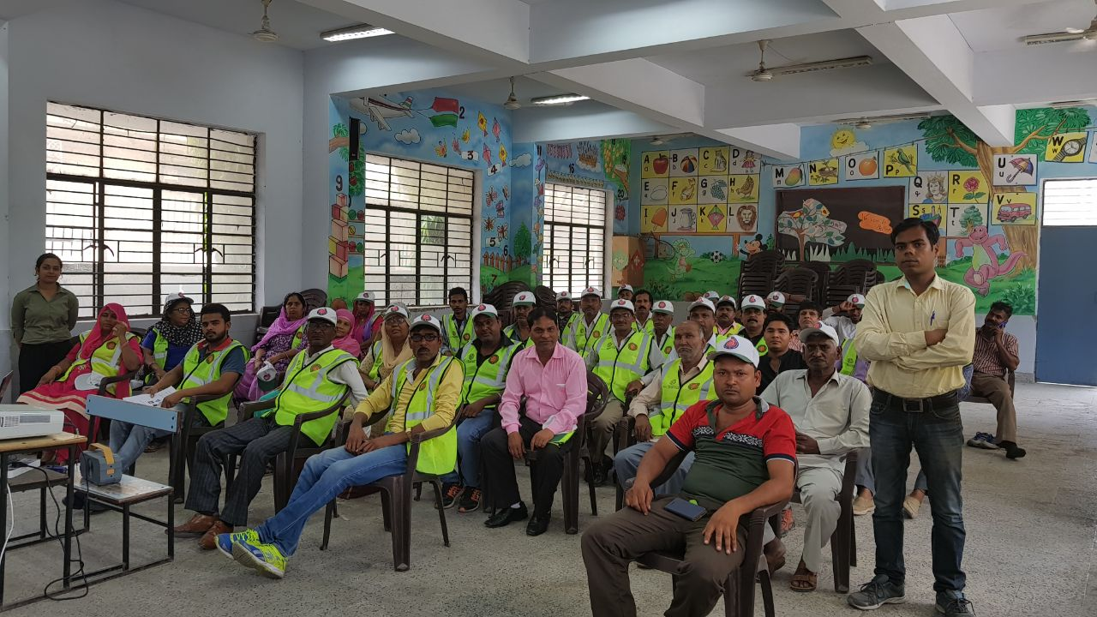

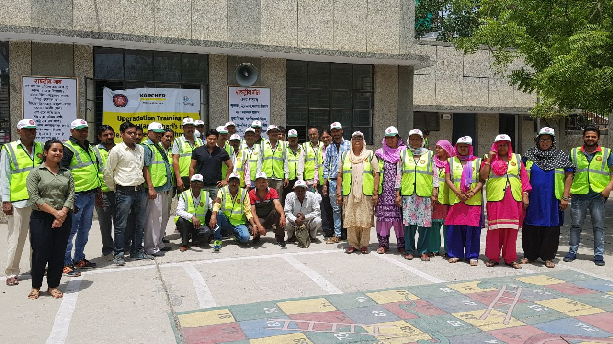

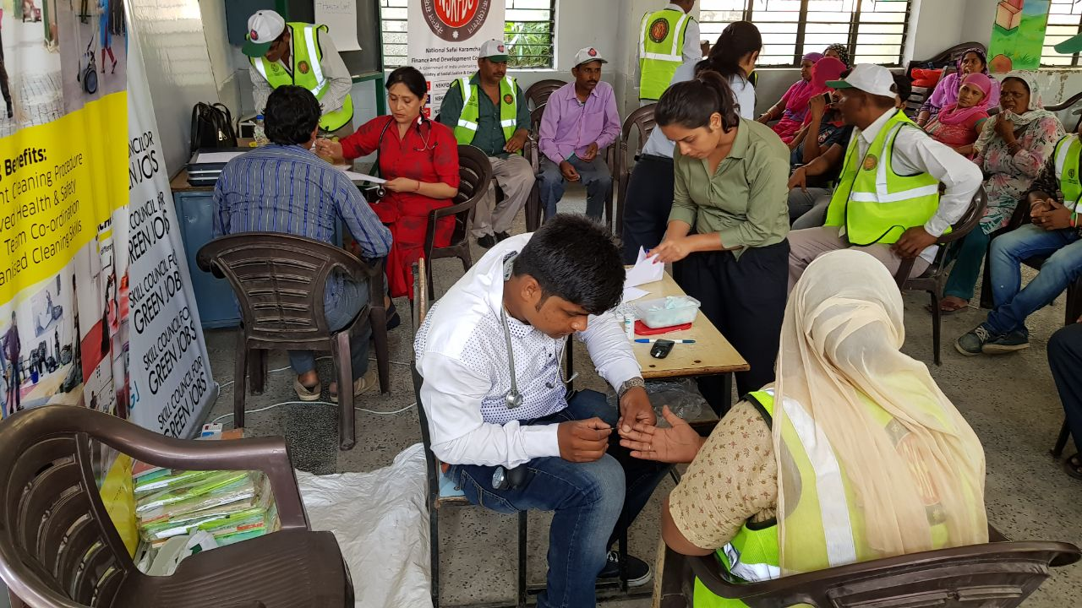

**Medical Examination**

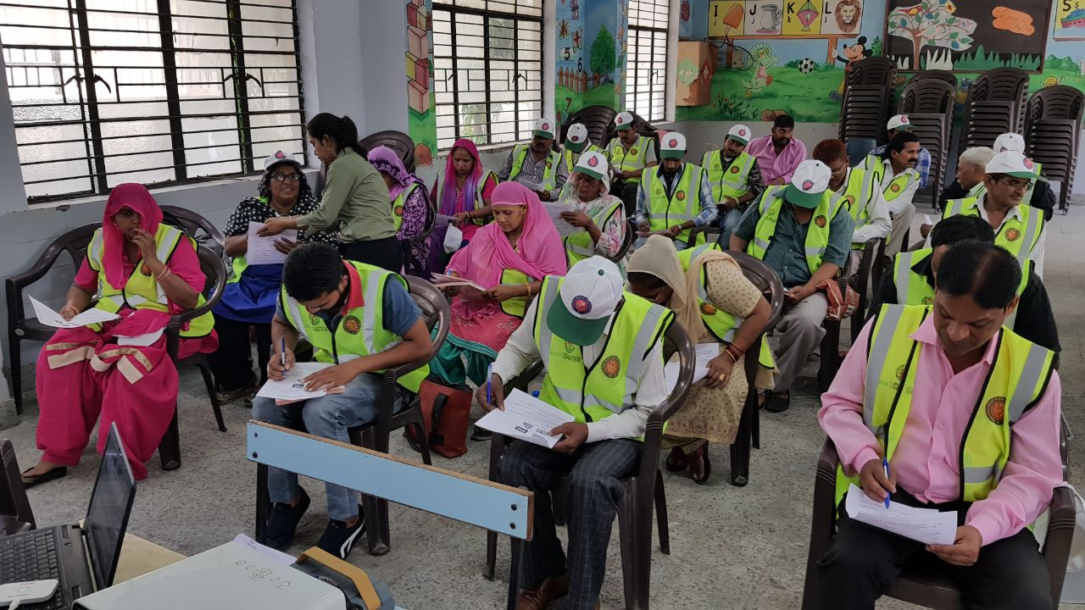

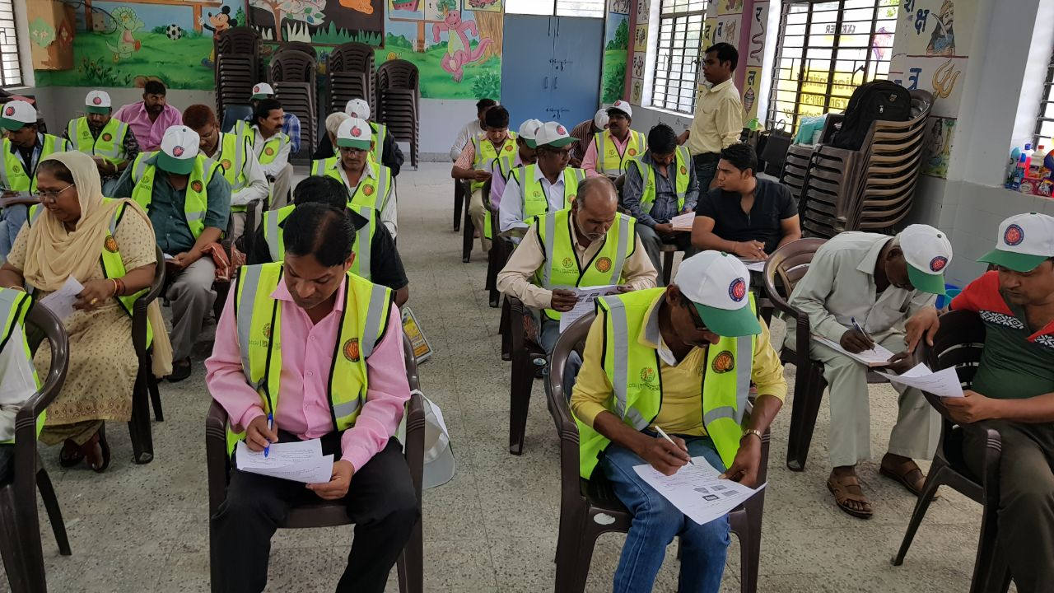

**Assessment of Candidates**

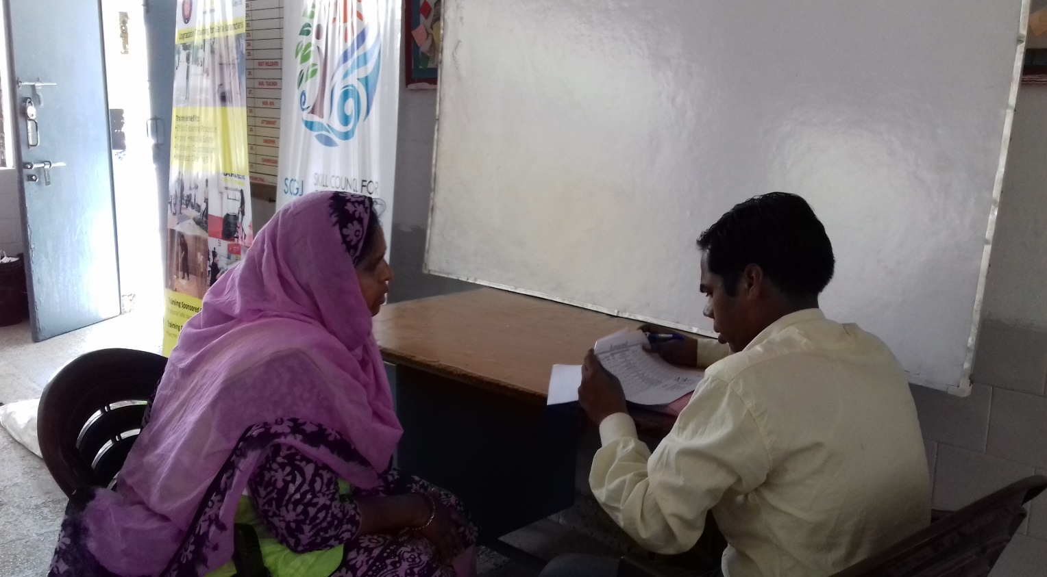

**Viva Examination of Candidates**

**Report of Training of Safai Karamcharis under RPL Programme**

**List of Candidates**

**Note:** For Batch 1 of Civil Lines with Batch ID: 402383, 49 candidates were approved and 38 candidates were successfully assessed in this batch.

|  |  |  |  |  |
| --- | --- | --- | --- | --- |
| **Name** | **Aadhar Number** | **Mobile No.** | **Candidate No.** | **Remark** |
| SUNIL | 528013991412 | 926858499 | 1 |  |
| GANESH KUMAR | 392864094465 | NA | 2 |  |
| RAJ RANI | 376145740371 | 9540560332 | 3 |  |
| Kishan Pal | 289352204436 | 9799704198 | 4 |  |
| BACHU SINGH | 586825965936 | 9716942021 | 5 |  |
| RAM KUMAR | 873762497766 | 989986595 | 6 |  |
| JAI PAL | 634366677784 | 9711765223 | 7 |  |
| VINOD | 269371948468 | 8375871969 | 8 |  |
| SAVITRI | 9242 0523 9605 | NA | 9 |  |
| RAJ DULARI | 3647 9776 8646 | 9868348764 | 10 |  |
| NAVEEN NUMAR | 5986 8964 3589 | 9911274559 | 11 |  |
| ISHWARI | 8385 0717 0616 | 9268182886 | 12 |  |
| ROHIT | 3483 1736 9764 | 9654476802 | 13 |  |
| SHEKH MUSTAFA RAHMAN | 5626 4999 0099 | 8800612694 | 14 |  |
| RAJPAL | 8967 5423 9970 | 8826569217 | 15 |  |
| KEHAR SINGH | 3315 6359 4410 | 9289218437 | 16 |  |
| ROSHAN LAL | 3022 9511 2372 | NA | 17 |  |
| RAJ RANI | 6349 0074 8799 | NA | 18 |  |
| OM PRAKASH | 5318 8151 6040 | NA | 19 |  |
| RAVI | 8891 4287 8159 | 8860282602 | 20 |  |
| SANDEEP | 5646 7800 1198 | 990316579 | 21 |  |
| SUNITA | 2589 4573 4810 | NA | 22 |  |
| SAGAR | 9142 2924 4390 | 9250465515 | 23 |  |
| DHARAMVIR | 8843 4464 4200 | 8706144367 | 24 |  |
| MANOJ KUMAR | 9412 3103 1988 | 9990627656 | 25 |  |
| MADAN | 6042 6737 7607 | 9851435123 | 26 |  |
| RAJENDRA | 3602 5025 4694 | 9891772102 | 27 |  |
| LALITA | 2296 6747 3648 | 7838416509 | 28 |  |
| VINOD KUMAR | 9200 6244 2976 | 9871046219 | 29 |  |
| DHARMENDER | 2817 9223 1098 | 9871046219 | 30 |  |
| MUKESH KUMAR | 3493 4619 8791 | 9871046219 | 31 |  |
| SURENDER | 4008 1050 4901 | 9810972453 | 32 |  |
| RAJESH | 8555 3432 6574 | 8800749967 | 33 |  |
| VICKY | 3131 2124 0679 | 9953551315 | 34 |  |
| JITENDER KUMAR | 6950 3848 1664 | 9910443720 | 35 |  |
| MANOJ KUMAR | 9709 7845 5519 | 9990627656 | 36 |  |
| RAJA | 3943 4276 6601 | 971027369 | 37 |  |
| RAJENDER SINGH | 3992 3726 0088 | 9910443720 | 38 |  |
| KRISHAN LAL | 921806778814 | NA | 39 | Absent |
| Prakash Singh | NA | NA | 40 | Absent |
| Raj Bala | 747519764318 | 9818699175 | 41 | Absent |
| NARENDER | 3068 1791 2398 | NA | 42 | Absent |
| Chand Singh | NA | NA | 43 | Absent |
| Bittu | NA | NA | 44 | Absent |
| Sunita | NA | NA | 45 | Absent |
| Anita | NA | NA | 46 | Absent |
| Lajwanti | NA | NA | 47 | Absent |
| Sanjay | NA | NA | 48 | Absent |
| Devraj | NA | NA | 49 | Absent |